Amadeus e-Power How To

Implement an IFrame and External Search Forms

**Index**

Introduction 3

IFRAME integration 4

EXTERNAL SEARCH FORM integration 5

# Introduction

This document describes the e-Power implementation guidelines for the travel agency’s website.

**General considerations**

**Before starting any implementation please read carefully the below recommendations:**

* **Page width:** in order to have the best view of all the e-Power pages it is recommended that the webpages width is set for **920 pixels** (the minimum value to have good look & feel is 780px if portal uses webpart elements) or to prepare a **full “iFrame”** page dedicated to e-Power integration.
* **Separate URLs for each travel service:** each booking type offered through e-Power (air / hotel / car) has its own entry points (URL’s) that allow a travel agency to promote services within separate sections of the website.

For example:

Long Form:

* <https://www-amer.epower.amadeus.com/amadeusna/#Page=Flight>
* <https://www-amer.epower.amadeus.com/amadeusna/#Page=FlightSchedule>
* <https://www-amer.epower.amadeus.com/amadeusna/#Page=Hotel>
* <https://www-amer.epower.amadeus.com/amadeusna/#Page=Car>
* <https://www-amer.epower.amadeus.com/amadeusna/#Page=Package>

Short Form:

<https://www-amer.epower.amadeus.com/amadeusna/#Page=Flight&SwitchAdvancedSearch=false>

<https://www-amer.epower.amadeus.com/amadeusna/#Page=FlightSchedule&SwitchAdvancedSearch=false>

<https://www-amer.epower.amadeus.com/amadeusna/#Page=Hotel&SwitchAdvancedSearch=false>

<https://www-amer.epower.amadeus.com/amadeusna/#Page=Car&SwitchAdvancedSearch=false>

<https://www-amer.epower.amadeus.com/amadeusna/#Page=Package&SwitchAdvancedSearch=false>

**You will need to replace amadeusna found in the example URLs above with your own portal code.**

* **Staging URLs:** all the testing should be performed on the staging site.
* **Production URLs:** This is the URL to embed on your website.

# IFRAME integration

At the moment the fastest way of e-Power integration is as follows:

* + IFrame code

For example on Drupal, create a basic page and enter the iFrame code with the height and width required for your site.

---------------------------------------------------------------------------------------------------------

<p><iframe frameborder="0" height="800" scrolling="auto" src="http://www-amer.epower.amadeus.com/**YOURPORTAL**/" width="1100"></iframe></p>

---------------------------------------------------------------------------------------------------------

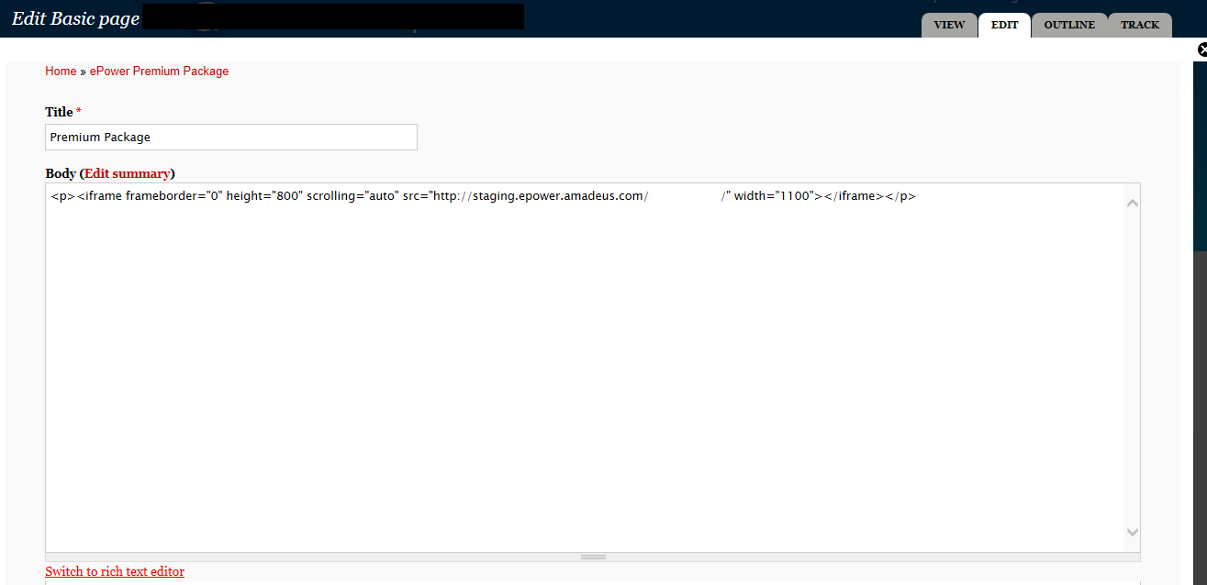

**Another iFrame example is shown below:**

<body style="margin:0px;padding:0px;overflow:hidden">

    <iframe src="[https://www-amer.epower.amadeus.com/**YOURPORTAL**](https://www-amer.epower.amadeus.com/YOURPORTAL)" frameborder="0" style="overflow:hidden;overflow-x:hidden;overflow-y:hidden;height:100%;width:100%;position:absolute;top:0px;left:0px;right:0px;bottom:0px" height="100%" width="100%"></iframe>

Advantages:

* This is the fastest and easiest way for the e-Power implementation
* It uses the whole options available in the e-Power search forms

Disadvantages:

* It uses the whole options available in the e-Power search forms
* No disadvantages known regarding loading performance or problems/restrictions in “look and feel”.

# EXTERNAL SEARCH FORM integration

Amadeus e-Power’s external search forms can also be integrated into a website.

**Amadeus deliverables:**

1. HTML file containing all the external parameters (mandatory or optional) needed to create the external search form.



1. Excel file containing all the city / airport / country / airline codes needed to create the destinations search scripts.



Your web developer is responsible for creating the form on your website. Please review the example form below to help you create one based on your portal needs.



Advantages:

* The external search form is hosted on the travel agency server -> no delays at initial loading of the search form;
* SEO compliant;
* Complete flexibility in terms of design customizations;

Disadvantages:

* Currently the following e-Power search options are not integrated within the external search forms: package search and car search based upon “locations” criteria.

Please take into consideration the following code types when building external search forms:

1. Flight search

* City or airport codes can be used for flight search.

1. Hotel search

* Only city codes can be used for hotel search.

1. Car search

* Only airport codes can be used for car search;

It is recommended to allow the end-user searching city names based upon using English and local names (e.g London / Londres).

The external search form should represent a mirror of e-Power original search form. Thus, for a better user experience, it is recommended to implement several validation items for the search form parameters.

- passenger types: the passenger types in the search form should be in line with the passenger types defined in the portal settings.

- calendar dates selection: the calendar should be restricted in line with the “Show availability starting from” option from portal settings.

***As a recommendation a full iFrame should be allowed for e-Power search results.***